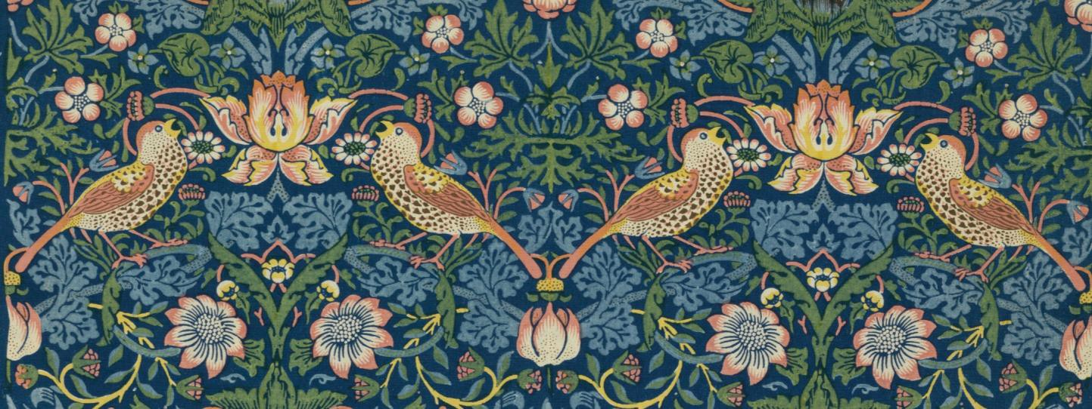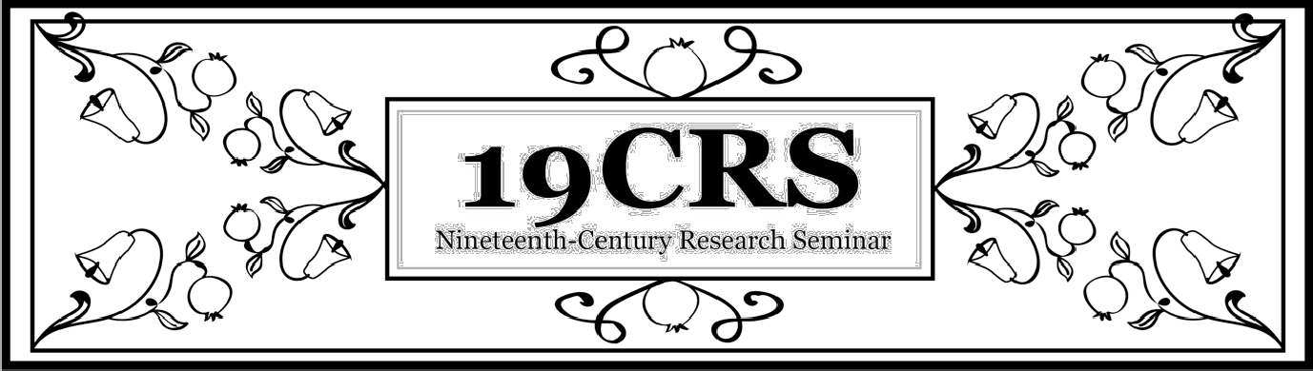

Oh the Places You’ll Go: Alt-Ac after Baylor
Thursday, March 31, 2022 | 2:00pm
Zoom

19CRS welcomes you to a virtual panel discussion on alt-ac careers after the humanities. Whether you're anxious about academic job prospects or curious about opportunities outside the college classroom, hear from five 19th- and 20th-century scholars on alt-ac careers they have found since teaching or studying at Baylor. We are bringing in representatives from industry, non-profit, teaching, publishing, and administration positions to talk about their path outside academia—how they got there, and how you might too.

Featuring

Dr. Christopher M. Rios
Associate Dean for Enrollment Management
Baylor Graduate School

Dr. Joe Stubenrauch
Instructional Designer
Amazon Web Services

Dr. Emily King
Acquisitions Editor
Fortress Press

Dr. Sara Dye
Project Manager, Criminal Justice Initiatives
Baylor Collaborative on Hunger and Poverty

Dr. Caitlin Lawrence
Instructor of Logic 1 Lit/Comp, History, and Grammar
Live Oak Classical School

Zoom information will be sent out before the event to the 19CRS email list or you can contact Dr. Kristen Pond at Kristen_Pond@baylor.edu for the Zoom link.

